We insert streaming data into bigquery using «streaming inserts». They insert elements one at a time into tables.

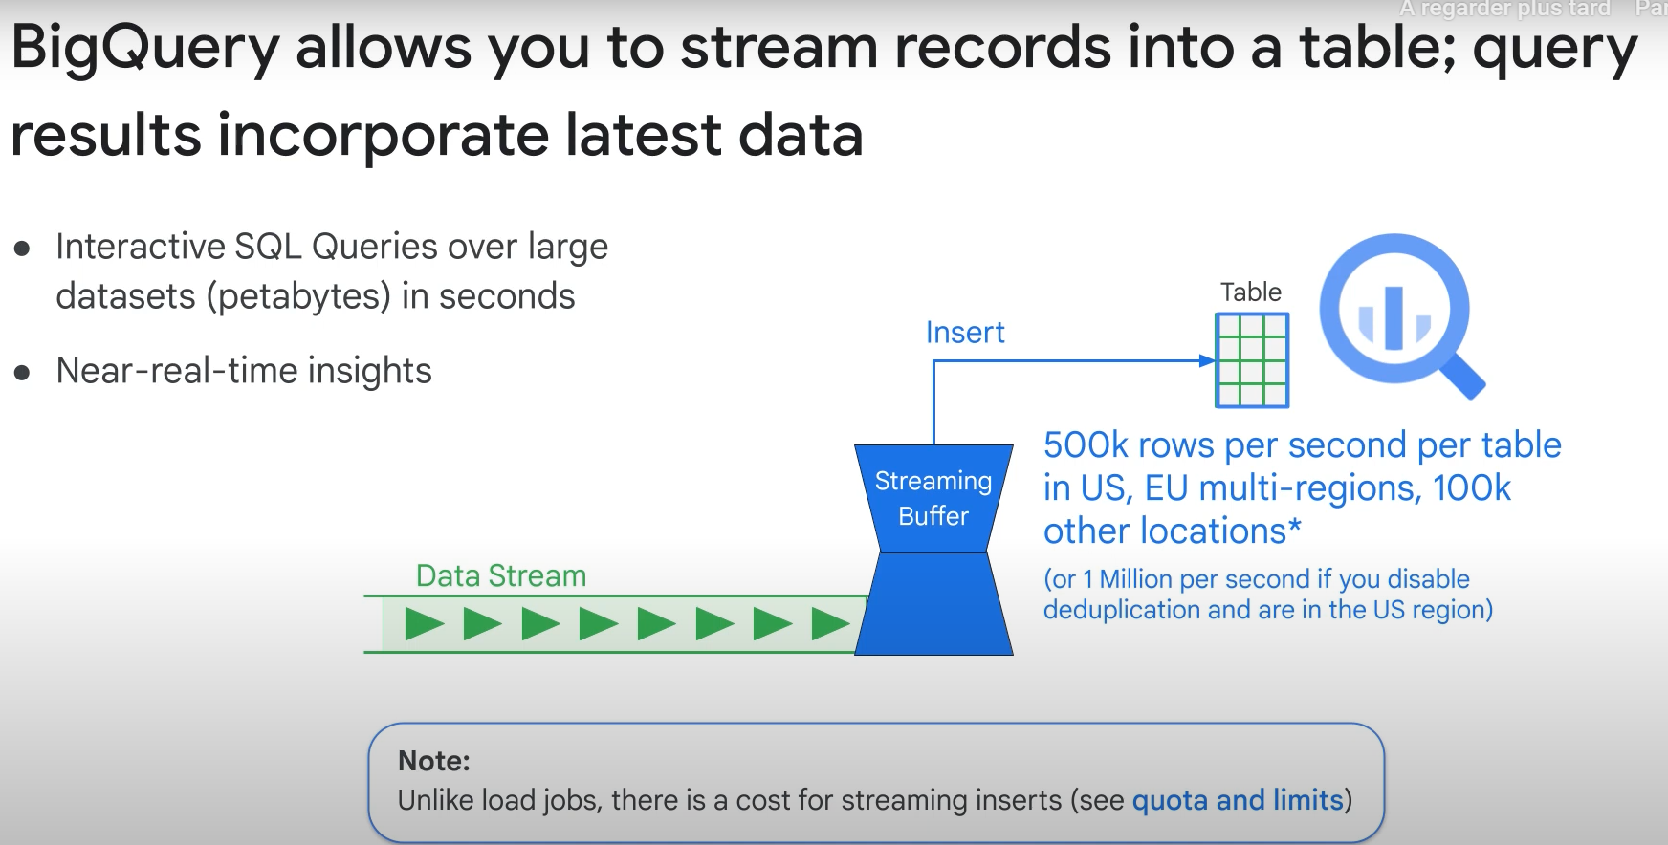

When to use streaming instead of batch reading of data? ==> When real-time use of data is required by your app.

BUT LOADING BATCH DATA IS NOT CHARGED (FREE), SO USE IT IF YOU DON’T REALLY NEED STREAMING!

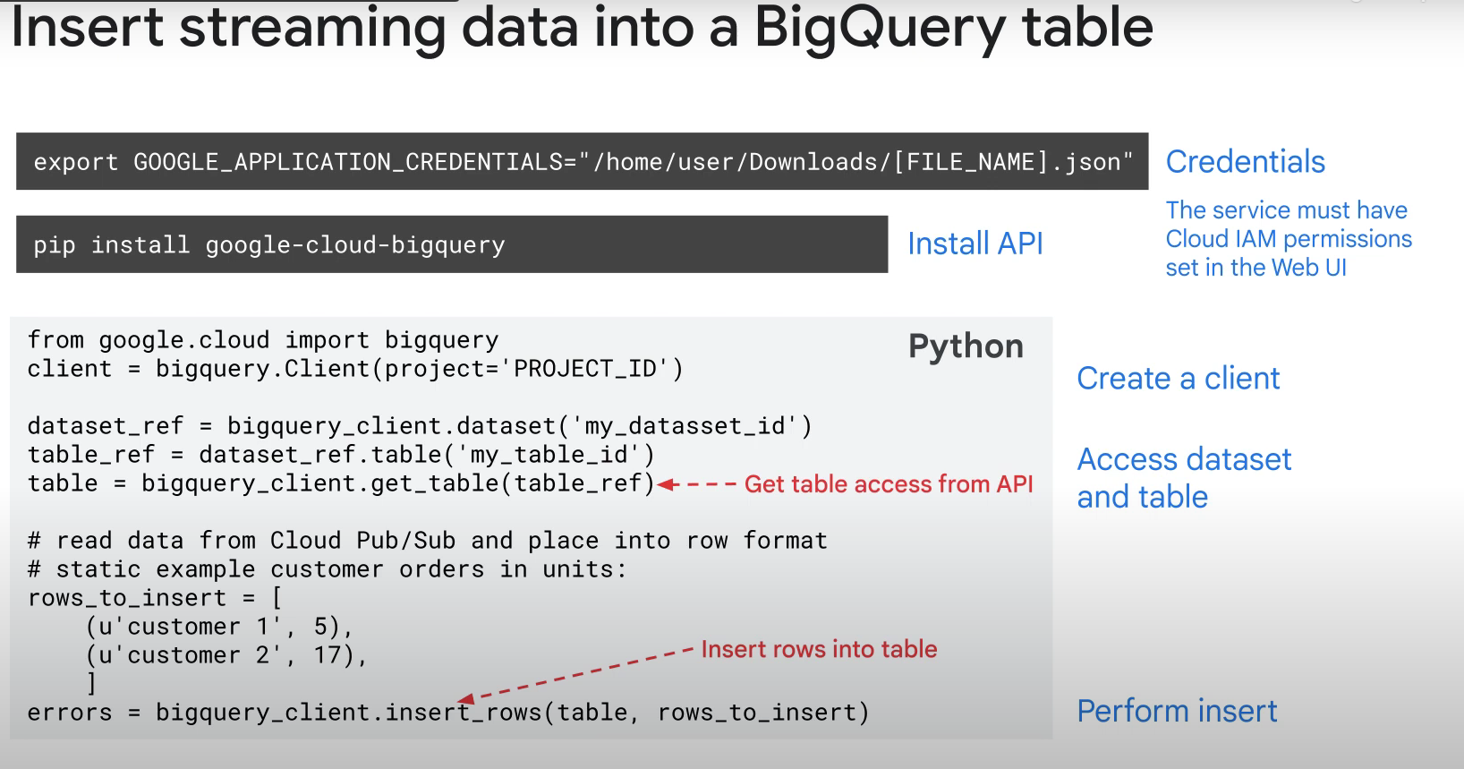

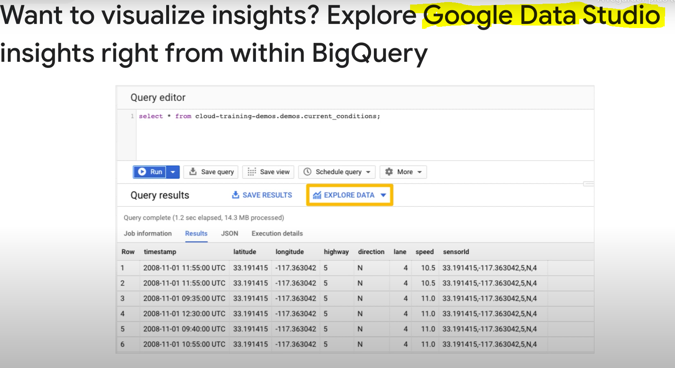

Google data studio is used to create dashboard/reports etc, to visualize data

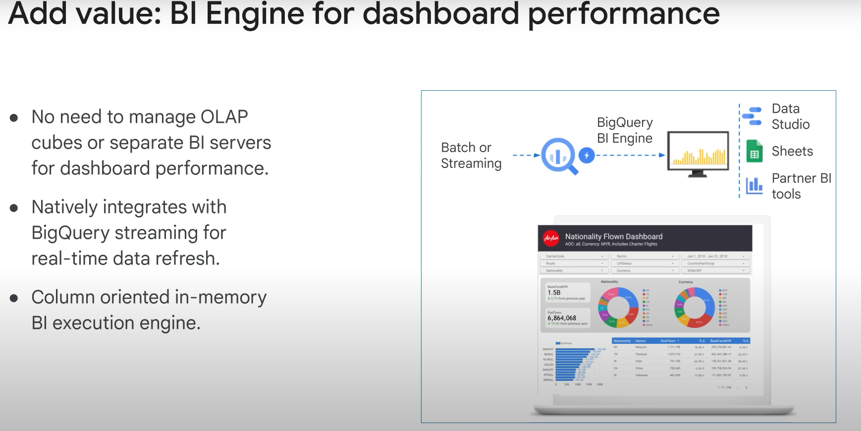

Column-oriented, just like bigquery.